**UML class and object Diagrams**

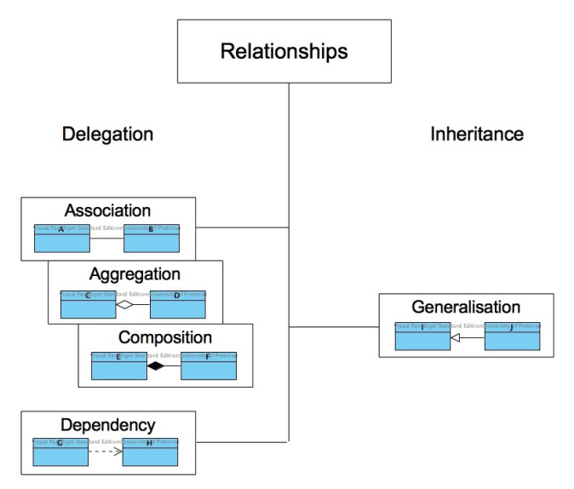

* Generalization = is-a

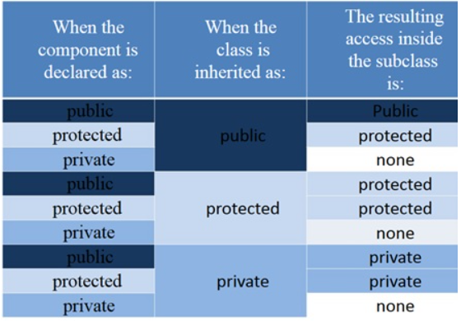

* object diagrams
  + are dependent on class diagrams
  + representing an instance of a class… with values
  + static (the name is underlined, how you identify an object vs class)
* relationships
  + 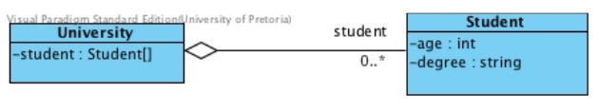
  + University have 0+ student
  + 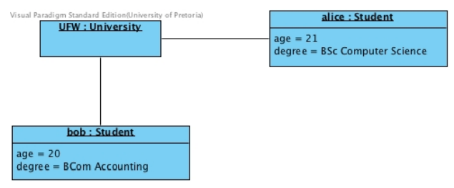
  + Object diagram